4 Nesting

<https://www.youtube.com/watch?v=_a5j7KoflTs>

Nesting is something which is considered by some to be one of the best things with SASS, but depending on how large the file is, you should be careful with using too much nesting.

Let’s take a look at our paragraph in the html file. You will see that we have a div, and that div has a class of main.

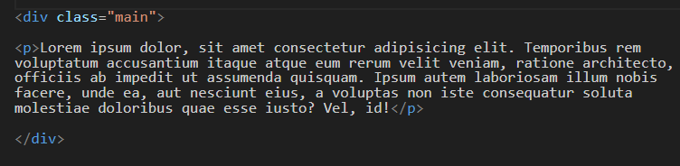

# To turn back on your Watch SASS

You might have to go back to settings, put SASS in the search bar, and go to the wheel here

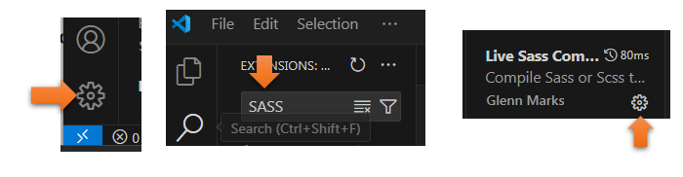

At the bottom, choose WATCH SASS

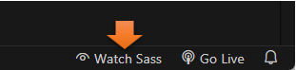

**Go to your SCSS file**

 .main {

        width: 75%;

        margin: 0 auto;

    }

**If your file is watching SASS**

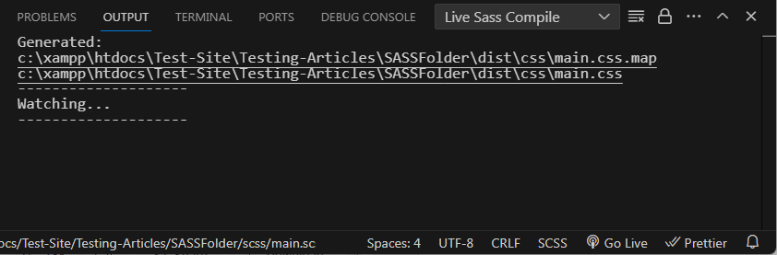

**You will see this written in your regular CSS**

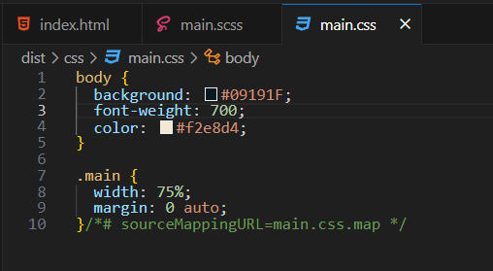

# This is how you Nest

When you nest, you can go inside of the rule that you just wrote for .main, and add these style properties to them. We want to target that paragraph in the html that we saw in the .main rule.

.main {

        width: 75%;

        margin: 0 auto;

    p {

        font-weight:map-get($font-weights, bold);

    }

    }

Look at what it wrote in the regular CSS file for us, when we made those changes in SCSS.

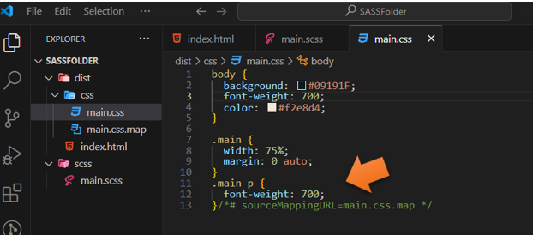

Go to the html file to test it, remember you will only get the file structure if you try to view the main.css file.

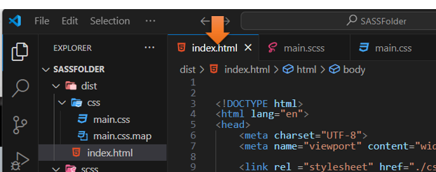

View it with the Live Server



And our text is now bold

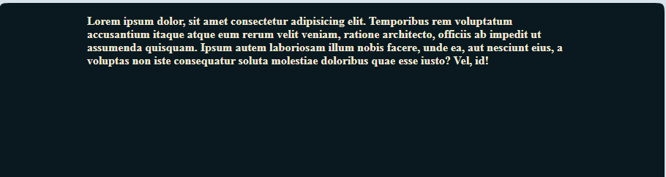

# Writing a Class instead of targeting the class directly

Go back to the SCSS and erase that part that we just wrote and change it to a class.

.main {

        width: 75%;

        margin: 0 auto;

    .main__p {

        font-weight:map-get($font-weights, bold);

    }

    }

Remember that with a class we also have to change it in the html to have a class attached to the paragraph.

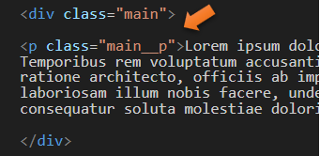

# Using the Shortcut of Ampersand $ when nesting

Look at how we used it in the SCSS

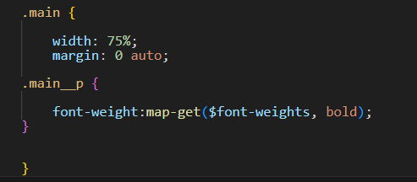

We can also write our SCSS code like this with the ampersand.

 .main {

        width: 75%;

        margin: 0 auto;

    &__p {

        font-weight:map-get($font-weights, bold);

    }

    }

But to actually write this ampersand thing out right, we need to have a pound sign before it and then wrap the ampersand in curly braces like this. Oh, and we are also adding a hover.

 .main {

        width: 75%;

        margin: 0 auto;

    #{&}__p {

        font-weight:map-get($font-weights, bold);

        &:hover {

            color:chocolate;

        }

    }

    }

Our regular CSS code will compile to this:

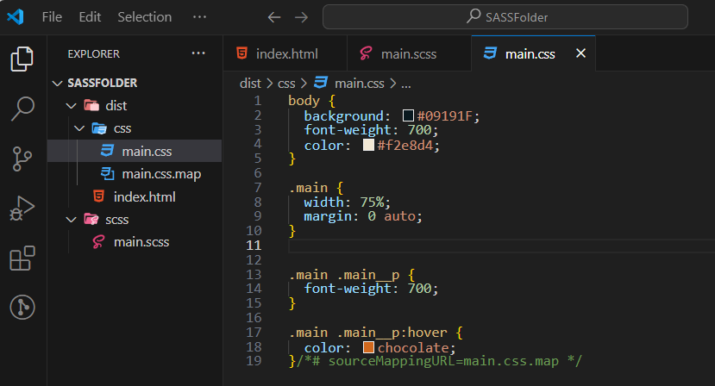

Go to the HTML file to view this in the browser

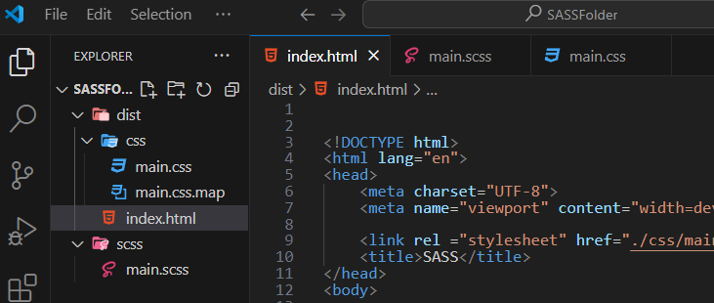

Live Server



And this is what it looks like:

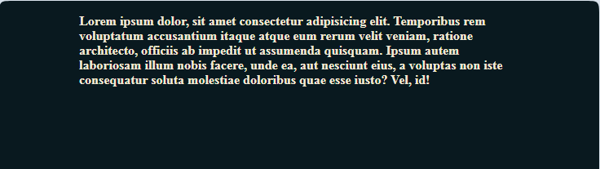

and when we hover:

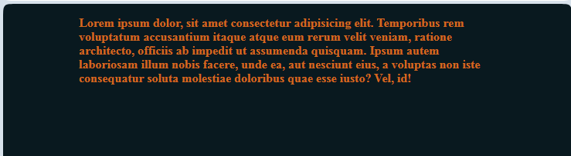

<https://www.youtube.com/watch?v=_a5j7KoflTs>

